LayeredFog is a post process effect that allows fog to be split up in a lower and upper part.

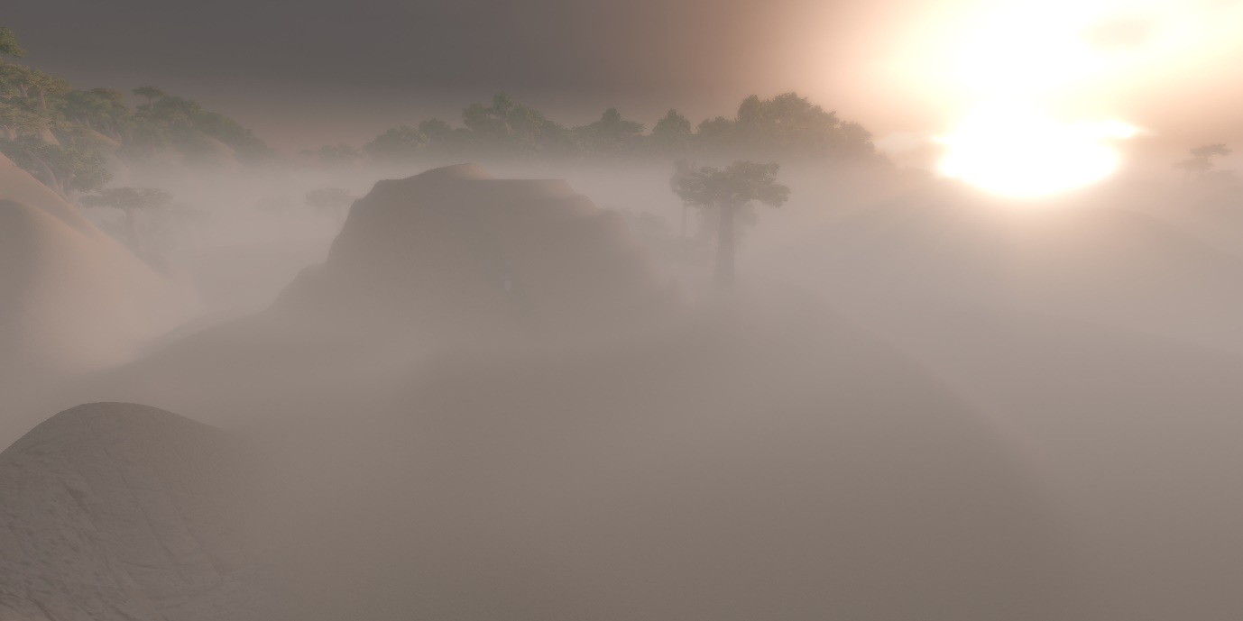

Usage

* Standard Unity preparations
  + Install the standard Unity post processing stack.
  + Add a Post Process Layer to the camera.
  + Ensure that the Post Process Layer has a layer set.
  + Create a new layer if a suitable one doesn’t exists.
  + Ensure the camera has the same layer selected.
  + Add a Post Process Volume to the scene.
  + Set the Post Process Volume to Is Global = 1.
* LayeredFog setup
  + In the Post Process Volume, add a new effect Voodoocado -> Layered Fog.
  + Enable all settings to be able to change them.
  + Set Fog Height Min/Max to suitable values for your scene.
  + For low fog, set Fog Density Below Min to 1.
  + Experiment with Fog Mode and Fog Distance until it suits your scene.
  + Check out the Demo scene to see how to control the fog runtime from script.